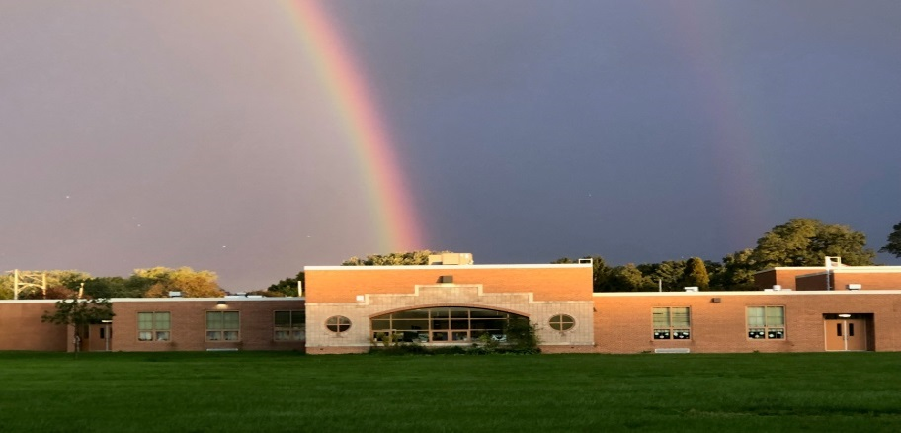
COMPREHENSIVE SCHOOL LEVEL PLAN
“Ensure that there is a system in the school that fully ensures the principal is enabled to serve as a strong instructional leader in partnership with the school community, leads achievement growth and continues improvement within the school.”
Specific School Strategies
2023-2024
- Comprehensive school improvement planning
  - Data analysis
  - Professional development
  - Implementation of strategies
  - Monitoring and adjusting
- School Wide Positive Behavior Support (SWPBIS)
  - Use of data
  - Common rules and expectations
  - Teaching and reinforcing expected behaviors
  - 4/1 positives to negatives
Specific School Implementation Steps
- Collect and review data
  - Achievement – PSSA, PVAAS, DIBELS, CDT
  - Behavior – Office Discipline Referrals, suspensions
  - Perceptual – Student, teacher, and parent surveys
- Professional development
  - The Power of Our Words – book study
  - Respectful Ways training
  - SWPBIS training
- Instructional Leadership Team/Professional Learning Communities
  - Shared decision making
  - Shared responsibility
  - Shared accountability

